**Question 1: Use finance to Extract Stock Data**

Reset the index, save, and display the first five rows of the **tesla_data** dataframe using the **head** function. Upload a screenshot of the results and code from the beginning of Question 1 to the results below.

Head data of tesla

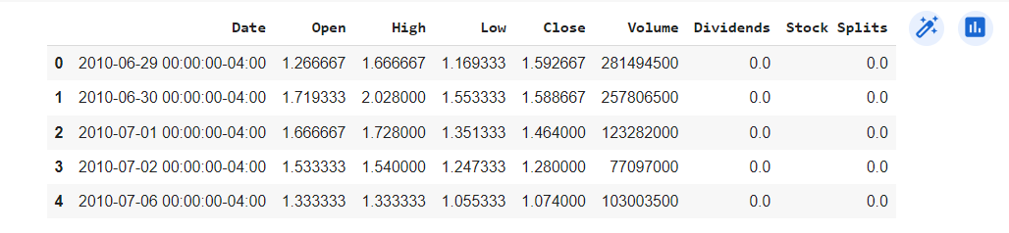

**Question 2: Use Webscraping to Extract Tesla Revenue Data**

Display the last five rows of the **tesla_revenue** dataframe using the **tail** function. Upload a screenshot of the results.

tail of tesla_revenue

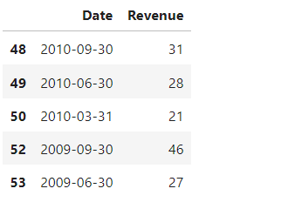

**Question 3: Use yfinance to Extract Stock Data**

Reset the index, save, and display the first five rows of the **gme_data** dataframe using the **head** function. Upload a screenshot of the results and code from the beginning of Question 1 to the results below.

head of gme data

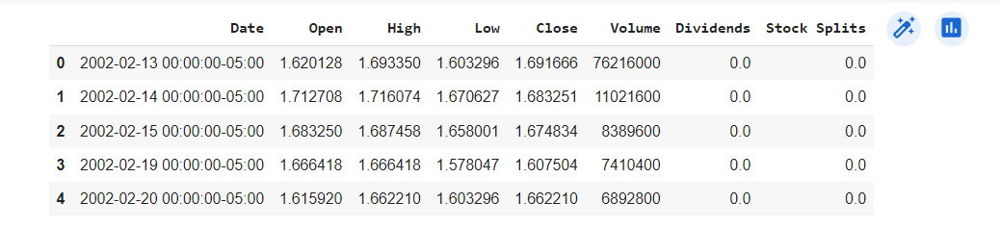

**Question 4: Use Webscraping to Extract GME Revenue Data**

Display the last five rows of the **gme_revenue** dataframe using the **tail** function. Upload a screenshot of the results.

tail of gme revenue

